**Tech-Hub Pay**

**(Low level Design Document)**

Contents

1. Introduction 3

1.1. Identification 3

1.2. Purpose 3

1.3. abbreviations 3

2. Diagrams 3

2.1. Workflow 3

2.2. Use case 4

2.2.1. Tech-Hub Pay 5

2.2.2. CBE 6

2.2.3. Bank 7

2.3. Class Diagram 7

3. APIs Document 7

# Introduction

## Identification

|  |  |
| --- | --- |
| Project Name | Tech-Hub Pay |
| Document Name | Low Level Design Diagram |
| Document Version No. | 1.0 |

## Purpose

This document contains the IPN simulation project (Tech-Hub Pay) details, it contains the diagrams that describe the workflow of the system and the activities of all component (Integration nodes) of the system along with the APIs document that every component should consume or expose.

## abbreviations

|  |  |
| --- | --- |
| IPN | Instant Payment Network. |
| IPA | Instant Payment Address. |
| CBE | Central Bank of Egypt. |

# Use case Diagrams

## Over all Workflow

This diagram is an overview of the whole system workflow

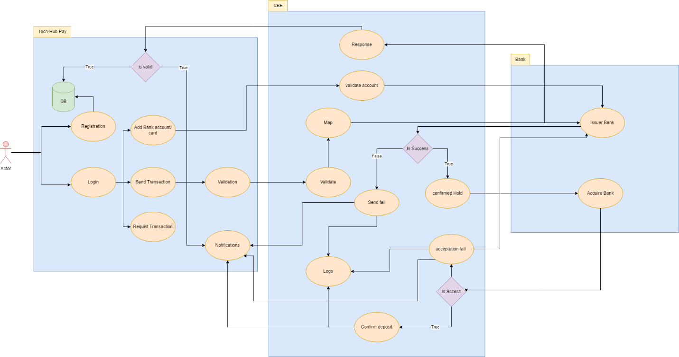

## Use case table

The Business Process workflow used in our system can be broken down into three tiers (Tech-Hub Pay – CBE – Banks)

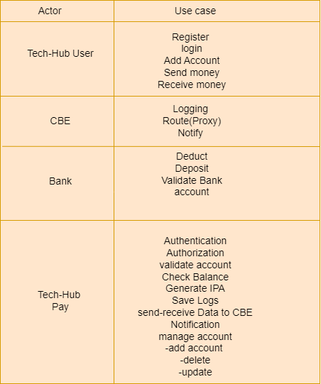

## Tech-Hub Pay

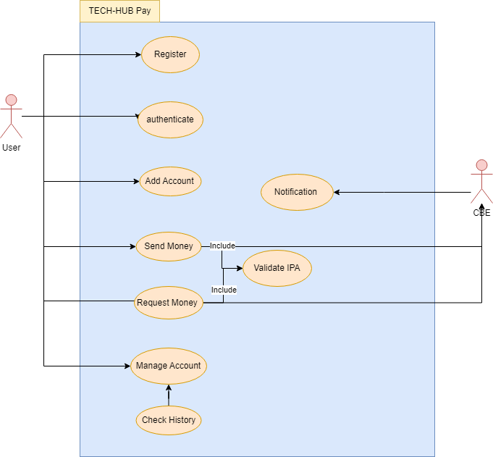

## CBE

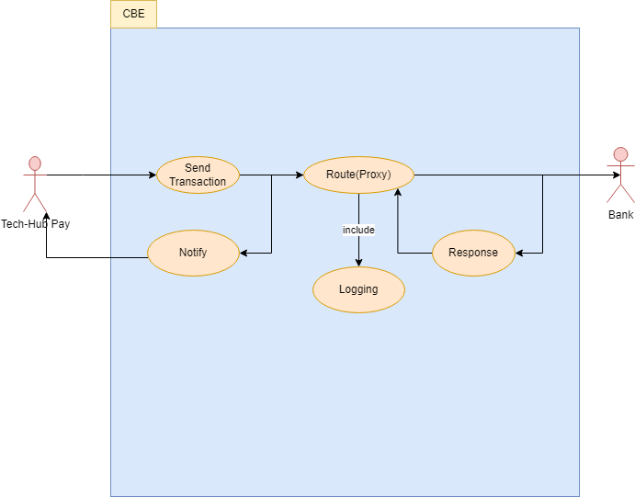

## Bank

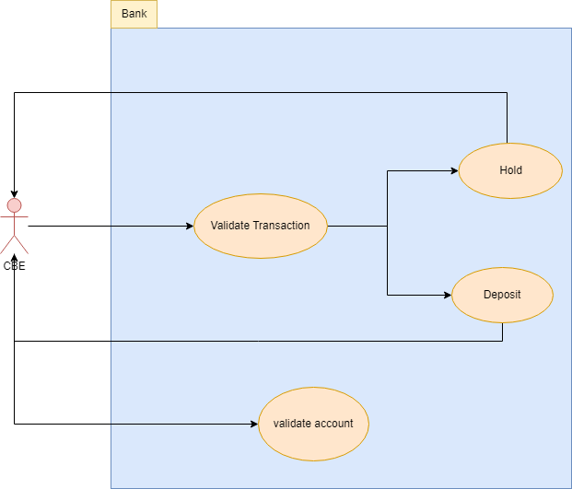

# Message flow diagrams

In this section we will explain the message flow between integration points.

## Validate new account

* + 1. 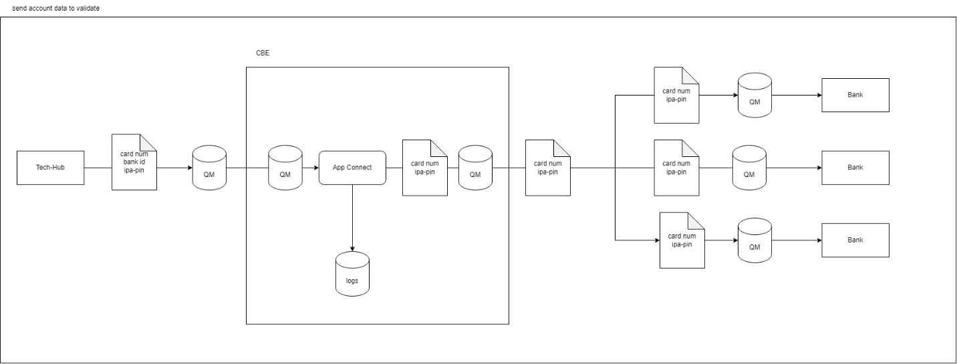 request message:
    2. 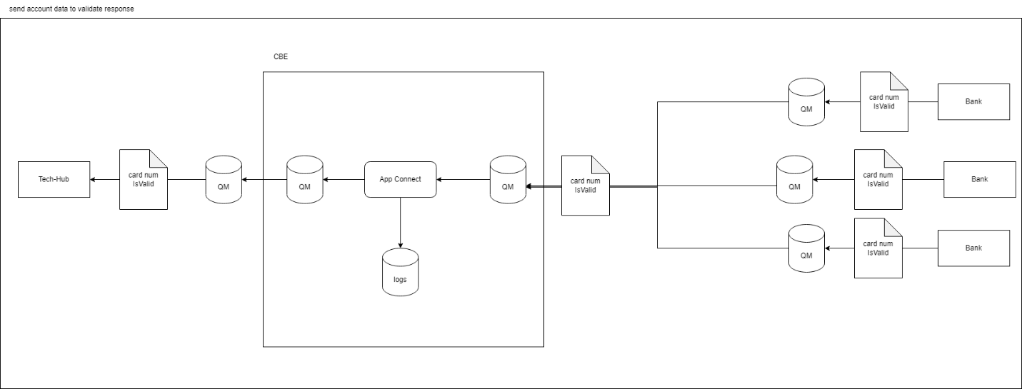 response message:

## Send/Request Transaction

* + 1. 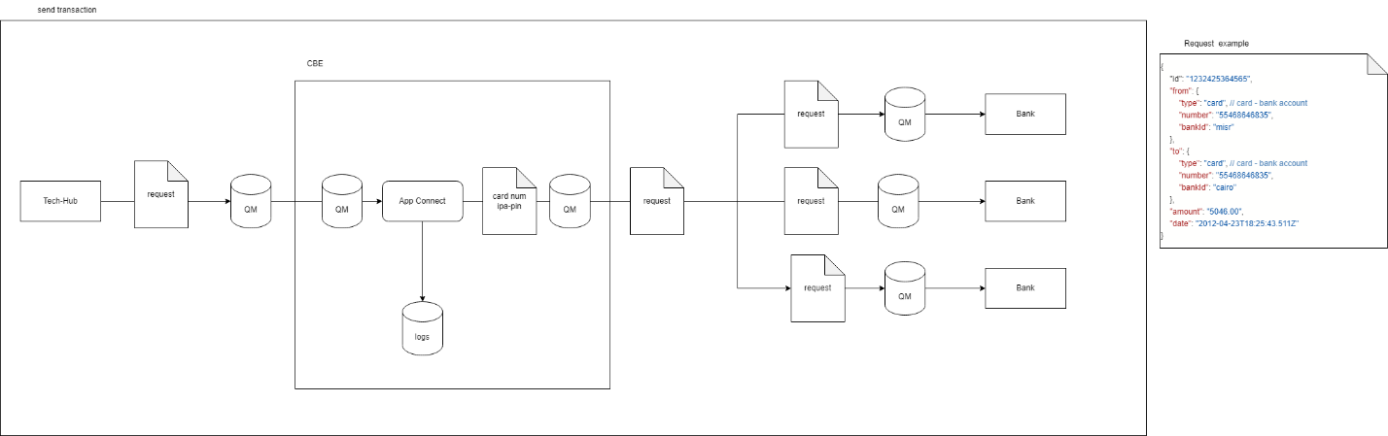 request message:
    2. 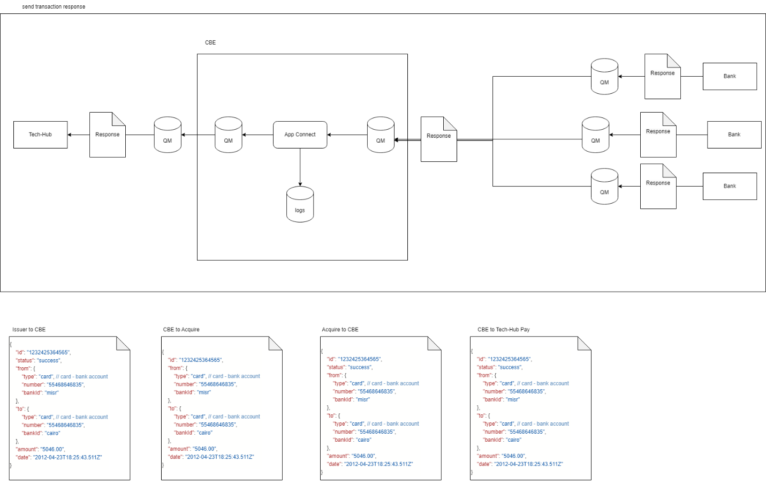 response message:

## Bank Account History

* + 1. request message: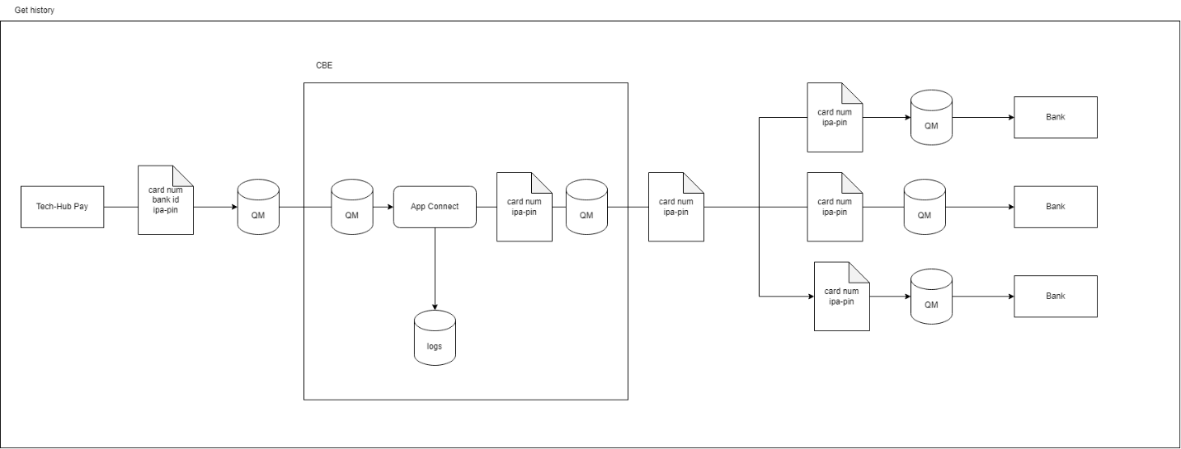
    2. 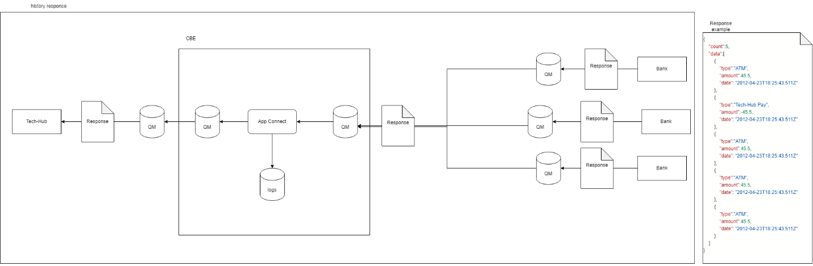 response message:

## Bank Account Balance

* + 1. 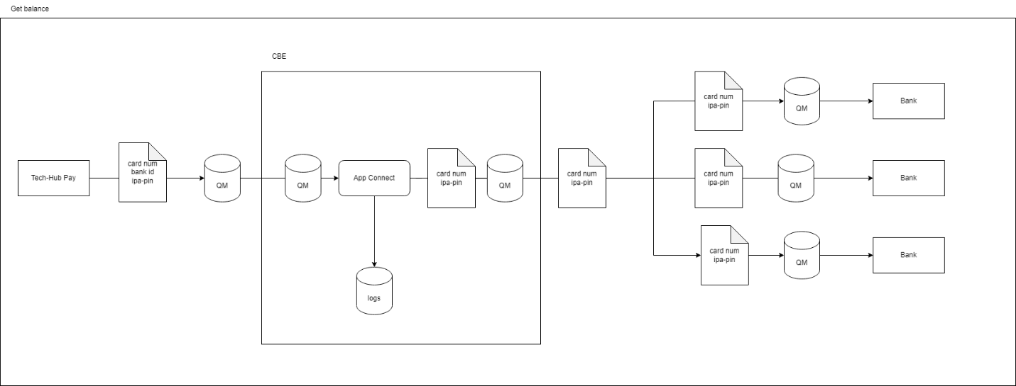 request message:
    2. 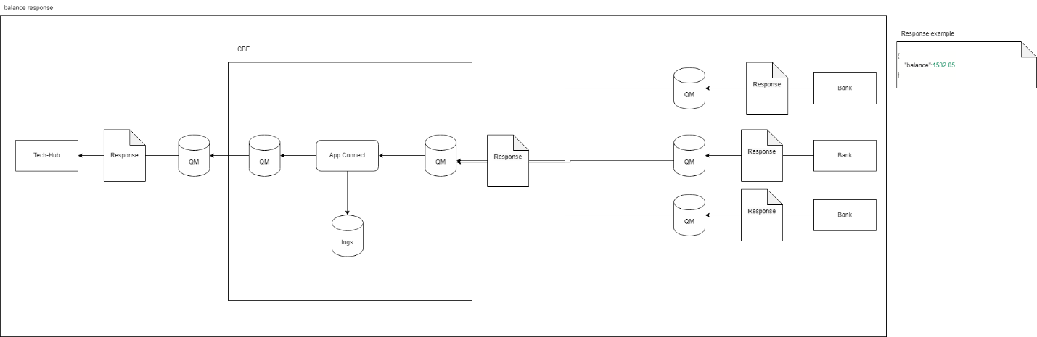 response message:

# APIs Documentation

The API documentation is published on the link below:

<https://documenter.getpostman.com/view/24434397/2s935hPRys>